- Account and User Management
CD 01: Create a Personal Checking Account
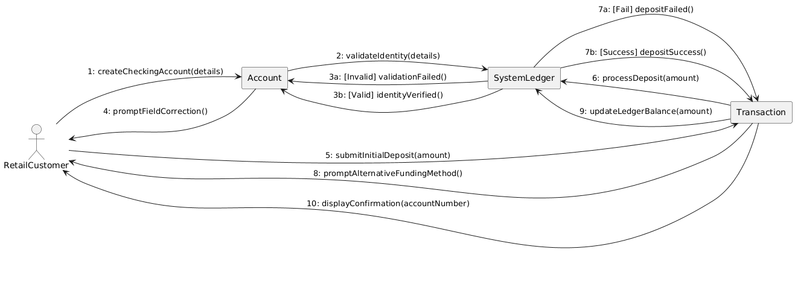
Made by: Orest Zeqollari

CD 02: Initiate Bulk Payroll Processing
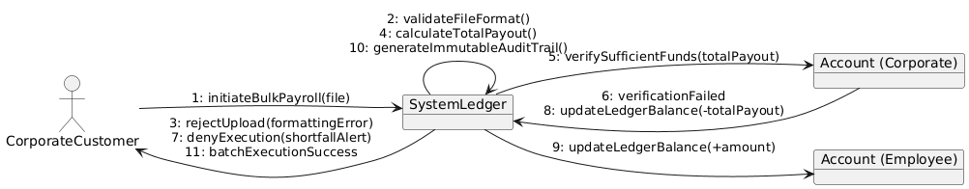
Made by: Orest Zeqollari

CD 03: Manage Multiple Authorized Signers

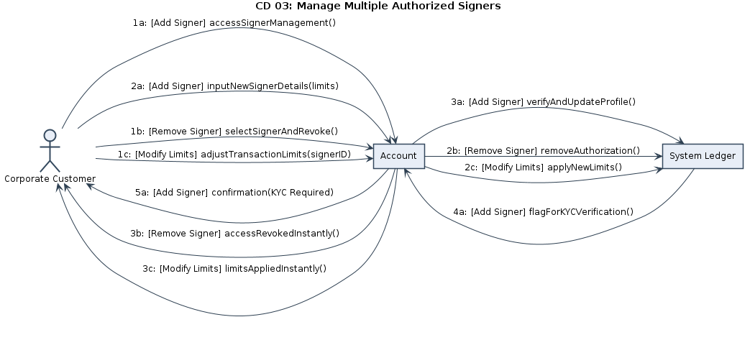
Made by: Orest Zeqollari

CD 04: Update KYC Documents
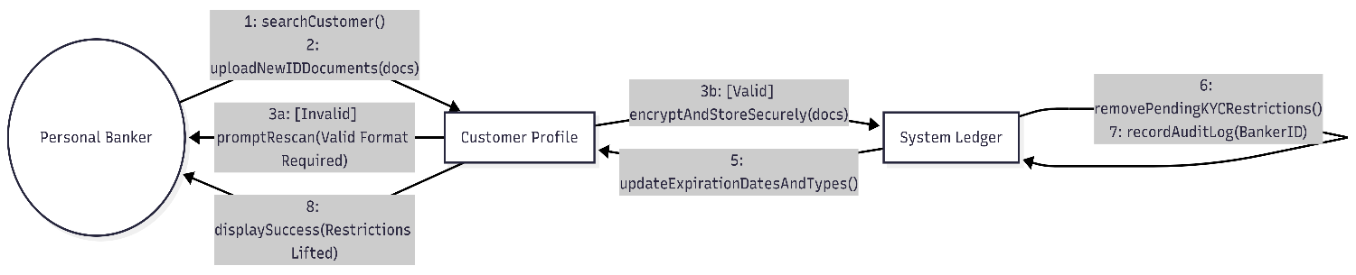
Made by: Aksel Luarasi

CD 05: Manage User Accounts (HR)
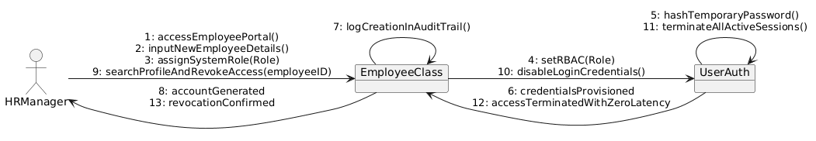
Made by: Aksel Luarasi

- Transactions and Cash Operations
CD 06: Process Cash Transactions

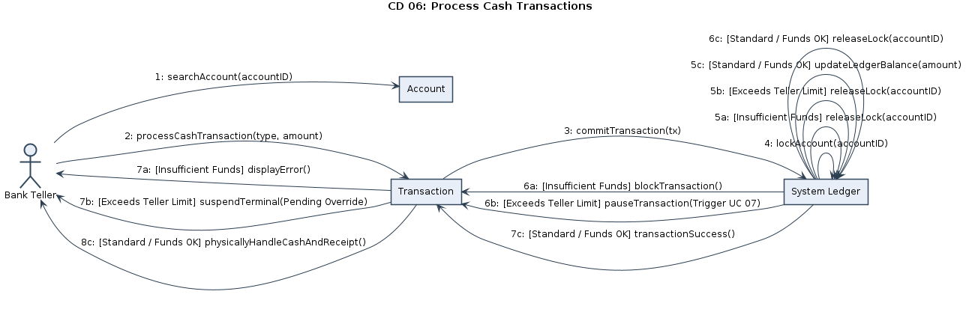
Made by: Aksel Luarasi

CD 07: Authorize Transaction Overrides
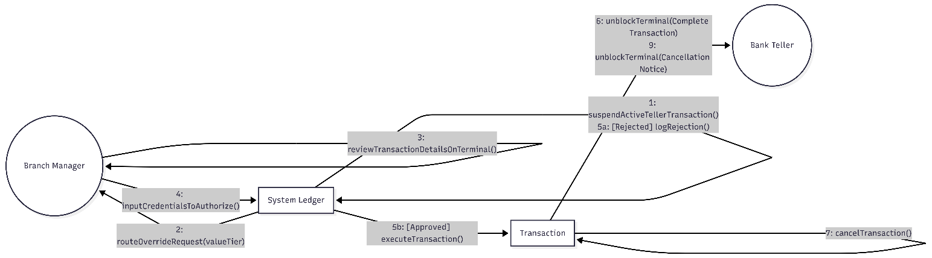
Made by: Kristian Avrami

CD 08: Manage Branch Cash and Vault Operations
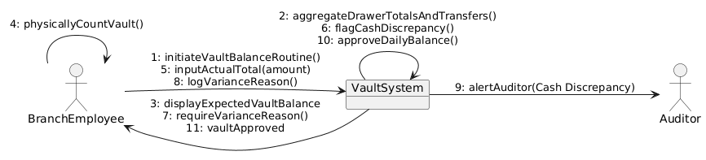
Made by: Kristian Avrami

CD 09: Settle External Transfers
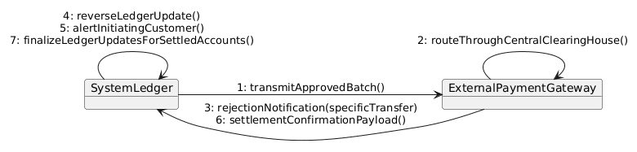
Made by: Kristian Avrami

- Credit & Loan Processing
CD 10: Evaluate Loan Applications
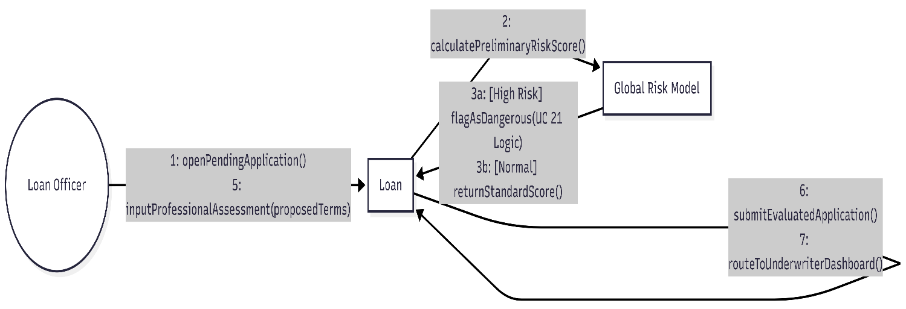
Made by: Erald Saraci

CD 11: Underwrite and Bind Loan Agreement 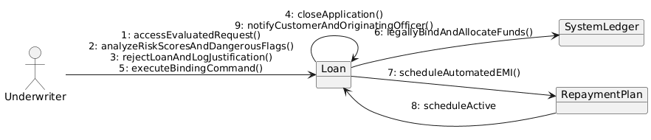
Made by: Erald Saraci

CD 12: Manage Defaulted Accounts and Asset Recovery
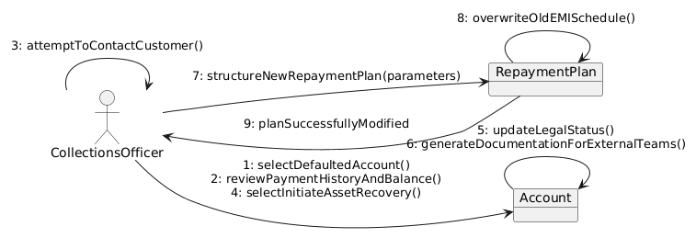
Made by: Denis Robi

- Monitoring, Security and Admin
CD 13: Monitor Transactions and Generate AML Reports
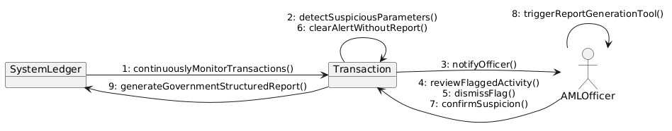
Made by: Denis Robi

CD 14: View Action History and Audit Logs
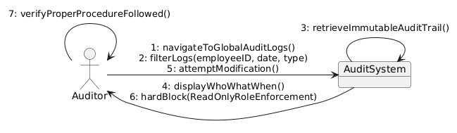
Made by: Denis Robi

CD 15: View Profitability and Transaction Summaries
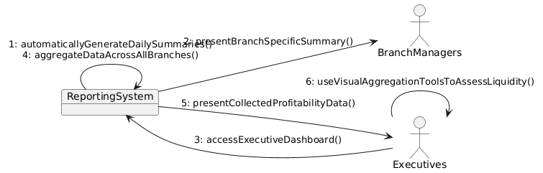
Made by: Denis Robi

CD 16: Manage Core System Configurations and Backups

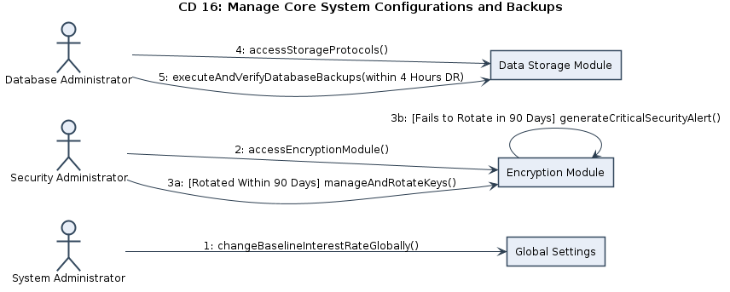
Made by: Daniel Salianji

- Remaining Core Operations & System Actors
CD 17: Generate Account Statements
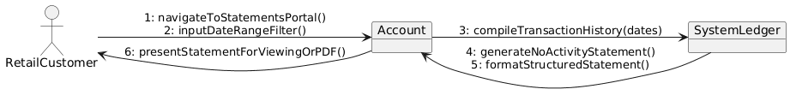
Made by: Daniel Salianji

CD 18: Issue New Debit Card
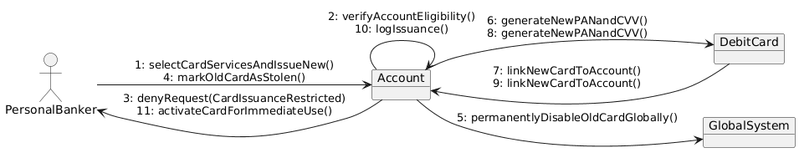
Made by: Daniel Salianji

CD 19: Authenticate User

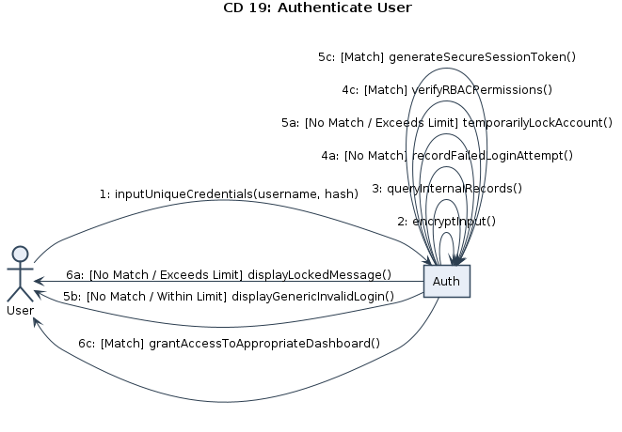
Made by: Denis Musaraj

CD 20: Set Global Risk Parameters
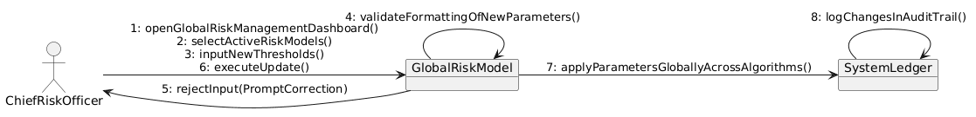
Made by: Denis Musaraj

CD 21: Flag Dangerous Loans (System Actor)

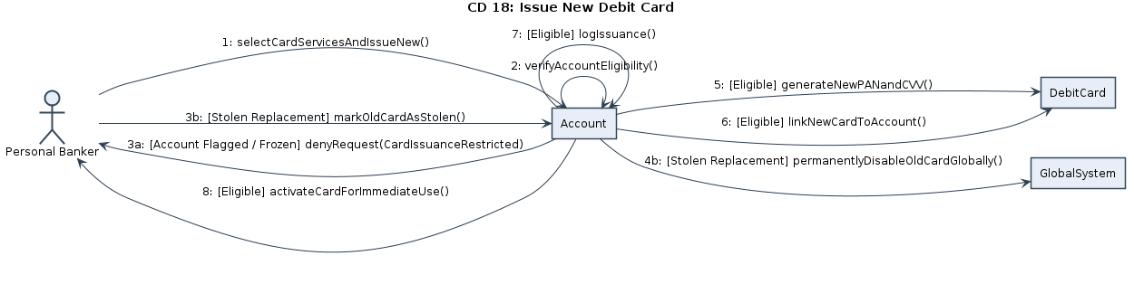
Made by: Denis Musaraj

CD 22: Route Loan Requests (System Actor)
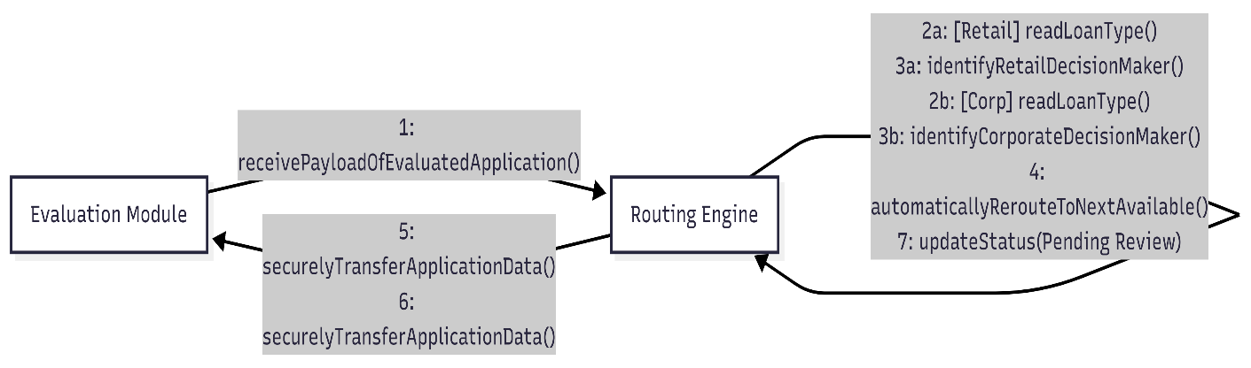
Made by: Dariel Hamzallari

CD 23: Update Ledger Balances in Real-Time (System Actor)
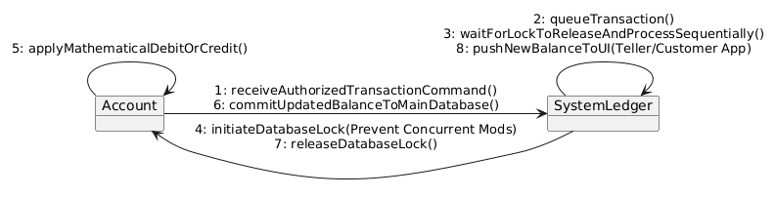
Made by: Dariel Hamzallari

CD 24: Generate Daily Transaction Summaries (System Actor)
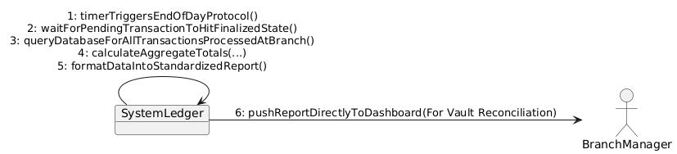
Made by: Dariel Hamzallari

